The HBP SGA3 Calls for Expression of Interest

“High-level neuro-symbolic processing for guidance of

goal-directed behaviour”

Proposal Template

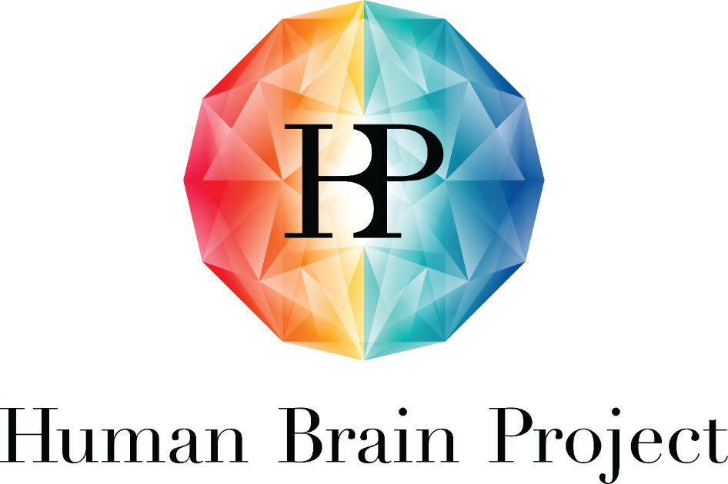

Project Number: | 945539 | Project Title: | Human Brain Project SGA3

Document Title: | HBP SGA3 CEoI – High-level neuro-symbolic processing for guidance of goal-directed behaviour – Proposal Template
Document Filename: | HBP SGA3 CEoI - Neuro-symbolic processing - Proposal Template
Dissemination Level: | PU = Public => please change this document to CO = Confidential after submission of the pre-proposal, here and in the footer
Abstract: | Calls for Expression of Interest for SGA3, Proposal Template
Keywords: | Working memory, attention, monitoring, task instructions, learning, distributed symbols, sub-symbolic rules, executive functions, frontal cortex
Target Users/Readers: | Applicants, all interested
Call Publication Date: | 5 August 2020
Pre-proposal Submission Deadline: | 16 September 2020 17:00 Brussels time
Proposal Submission Deadline: | 16 October 2020 17:00 Brussels time
Proposal submission online platform | HBP Open Call Platform
Total Call Budget: | EUR 450,000 Direct Costs. Maximum funding per proposal: EUR 450,000 (PLUS 25% Indirect Costs), one proposal will be selected.
More information: | info@opencalls.humanbrainproject.eu

Instructions:
This template is for proposals made in response to the HBP CEoI for SGA3.
Page limits refer to this text style (Body Text HBP) in MS Word:
- Font: Trebuchet MS 11pt
- Line spacing: single
- Paragraph spacing: 6pt before and after
- Page size: A4
- Margins: according to this template
- Page limit: 18 A4 (plus 1 page per additional Partner).
Letters of support can be added to the proposal. These letters will be considered as appendices, which do not count towards the page limit.
This form must be submitted electronically any time before 16.10.2020 17:00 Brussels time to the HBP Open Call platform. Budgetary information must be provided via the electronic submission platform.
Instructions (in red) should be deleted.

Table of Contents

1. Proposal information 5
2. Abstract 5
3. Scientific excellence and impact 5
3.1 Methodology 5
3.2 Contribution of the proposal 5
3.3 Relevance to the aims of the Human Brain Project 6
4. Implementation 6
4.1 Structure of the Work Plan 6
4.2 Description of the Work Plan 7
4.3 Quality of the Organisation 7
4.4 Resources to be committed 8
4.5 Cost and funding breakdown by participating organisation for the specific time frame 8
5. Equal opportunities 8
6. Ethical implications 9
ANNEX: SGA3 Project Objectives and Work Package Objectives 10

Table of Tables
Table 1: Proposal Consortium 5
Table 2: Proposal Work Plan 6
Table 3: Proposal Work Plan description 7

Proposal information
Proposal name:
Proposal acronym:
Table 1: Proposal Consortium
Project coordinator (contact person)
First and last name
Email
Affiliation and short name
Country
Project partner 1
First and last name
Email
Affiliation and short name
Country
Please extend the table for each partner of the consortium.

Abstract
NOTE: length limit = 1 A4

Scientific excellence and impact
Describe the contributions you will make to research, its excellence, the expected results of your future activities, how you go beyond the state of the art and the expected impact to the field. Show how you are uniquely positioned to accomplish the objectives of the proposed work plan.
NOTE: length limit for this chapter, including diagrams, images, etc. = 10 A4

Methodology
In this section, describe the methodology you will use to accomplish the activities listed in the Guide for Applicants and to reach the expected contributions. Explain the methodology in detail and state how it relates to your experience in other similar contexts.

Contribution of the proposal
Describe the contributions you will make to the HBP and the expected results of your future activities. Explain how they relate to the specific SGA3 Objectives (see ANNEX: SGA3 Project Objectives and Work Package Objectives at the end of this document).
Define your interaction with the existing Work Packages of the HBP. Explain in detail how your work contributes to or makes use of EBRAINS and its Service Categories. Show that your work brings new, unique elements to the HBP.
Your proposal should especially address the following aspects, as further detailed in the Call: the eligible scope of the work to be conducted includes the implementation of network modules for working memory, attention and executive functions in collaboration with other partners of WP3. The applicants should detail, within this spectrum, what specific aspect(s) they intend to focus on (e.g. working memory, dynamic routing and broadcasting, attentional selection and gating, hierarchical planning, learning of abstract representations, rule-like processing) and how their implementations help to support goal-directed actions in (virtual) robotic agents. They should also clearly articulate how they want to implement such structures and functions in biologically inspired neural networks and how modules and achieved functionality relate to brain structures and mechanisms where possible.

Relevance to the aims of the Human Brain Project
In this section, describe the benefits and added value of your approach and the knowledge generated for the HBP as a whole, and for its research infrastructure EBRAINS and possible user communities in particular.
For a more detailed description of the current EBRAINS Service Categories, please refer to the supplementary document “HBP SGA3 CEoI - Work Plan and Outcome Overview” (see Call page).
For all aspects, please provide evidence of your specific expertise.

Implementation
NOTE: the length limit of chapter 4, including diagrams, images, etc. is 5 A4 (plus eventual extra A4 pages per additional partner only for section A4.3), split as follows:
- sections 4.1 and 4.2, including diagrams, images, etc.: 3 A4
- section 4.3: 1 A4 per Organisation (plus 1 page per additional Organisation/Partner)
- section 4.4 including diagrams, images, etc.: 1 A4 of text (excluding the online budget tables)

Structure of the Work Plan
The proposed Work Plan should include one Task, one to three Outputs, one or two Milestones and one or two Deliverables. The Task Leader, being the Project Coordinator or leading Principal Investigator of the proposal, plus its organisation need to be clearly identified. The planning should be sufficiently detailed to justify the proposed effort.
Table 2: Proposal Work Plan
Work Plan for <Proposal Name>
Task <Name>
<Lead Partner>
Task Number <Tx> | Task <Name> | Lead Partner / PI | Start Month | End Month
Output Number <OPx> | Output <Name> | Lead Partner / PI | Lead Partner | Due date (Month)
Milestone Number <MSx> | Milestone <Name> | Means of verification | Lead Partner | Due date (Month)
Deliverable Number <Dx> | Deliverable <Name> | Description | Lead Partner | Due date (Month)
Please extend the table as needed.

Description of the Work Plan
Describe the work you propose for the period of 24 months. Contribution to the project activity reports will be required from the new Partners; for example, Technical Periodic Reports or reporting on resources used in the period (Financial Periodic Reports). Your work will figure in ONE Task in the Work Package.
Table 3: Proposal Work Plan description
Work Plan for <Proposal Name>
Task <Name>
<Lead Partner>
Insert your concrete (SMART ) Objective for the Task. Describe how you would reach the Objective and how you would measure the results, e.g. the method you will use, the Milestones of your work, etc. This will become your Task description in the SGA3 Description of Action (DoA).
Task Number <Tx> | Task <Name> | Lead Partner / PI | Start Month | End Month
Task descriptions should contain, in three separate sections:
- Objective of the Task
- Methods to be used by the Task
- Outputs (list of Outputs generated by this Task or to which this Task contributes)
Interactions with the other WP and their Objectives.
The proposal should interact with other WPs, contribute to the achievement of Work Package Objectives (see ANNEX). Please provide a short description for each relevant interaction.
HBP WP number/ WP Objective | Description
Please extend the table as needed.

Quality of the Organisation
NOTE: length is limited to 1 A4 per Organisation.
In this section, describe the quality and relevance for the HBP of your Organisation/Group and what expertise it will bring to the HBP Consortium that is not already available. In particular, your proposal should address the following points:
- Brief description of the Organisation
- Brief description of the participating group/lab and their previous relevant experience to the task in the proposed work.
- Short profile of the main individual who will undertake the work, demonstrating their qualifications with respect to the task at hand.
- Up to five relevant publications. (NOTE: no extra annex for references is allowed!)
- Characterise the co-funding/proposed in-kind contributions the proposal will bring to the project (approximately EUR 200,000).

Resources to be committed
NOTE: length is limited to 1 A4 of text, excluding the online budget tables.
You should address the following points:
- Describe how the totality of the necessary resources will be mobilised in the defined time frame including your own resources which you will be providing to complement the EU contribution.
- Identify personnel costs and any major non-personnel direct costs, and explain why they are necessary for the activity you propose. Justify equipment to be purchased, describe travel expenses, and other major cost items.
- Indicate whether you will include subcontracting costs, justify them, and state what they are and their amount. Subcontracting costs are not subject to indirect costs. Please note that you cannot subcontract core activities. Services purchased in the frame of the funded activity only count as subcontracting if they consist in a part of the task to be accomplished. Support of the activity, such as event organisation or software development, is not a subcontracting cost, unless the activity implicitly involves such activities.
- A Voucher of EUR 45,000 is foreseen to fund technical support for integration of project results in EBRAINs, which will be performed by the HBP High Level Support Team (HLST). Include this Voucher in your budget table, justify the possible usage. Please allocate the Voucher to the internal partner(s) if there is any.

Cost and funding breakdown by participating organisation for the specific time frame
Please fill the online budget table for every partner of your application. The online budget table will be manually added by the Open Call Management team to your proposal upon submission.

Equal opportunities
NOTE: length is limited to 1 A4.
Please provide the following information:
- For teams, is the diversity aspect (gender, age, career stage, other factors) taken into consideration/ are there any measures in place? If there is a gender imbalance, are measures planned to improve gender equality? See Table 1 - Criterion 4 in the Guide for Applicants (see Call page).
- In research activities when human beings are involved as subjects or end users, gender differences or other diversity factors may exist. In these cases, is the gender dimension and relevance of scientific questions on gender or other diversity factors (e.g. age) in the research content addressed as an integral part of the proposal? See Table 1 - Criterion 1 in the Guide for Applicants (see Call page).

Ethical implications
NOTE: length is limited to 1 A4.
Describe the ethical implications of your work and compliance with applicable international, European, and national law. Indicate which ethical approvals the project already has in place or will need to apply for. The proposal should also describe an approach to handle and mitigate possible risks related to data protection.

ANNEX: SGA3 Project Objectives and Work Package Objectives
Project Objective | Work Package Objective
PO1. Establish a sustainable European scientific research infrastructure, EBRAINS, leading to an increased use and adoption of FAIR data, web-based analyses, model building, simulation, atlasing, and virtual experiments for brain research and brain-inspired sciences. | - WPO4.1. FAIR data services: Access to and storage of high-quality neuroscientific data, facilitating data re-use in the scientific community  - WPO4.2. Brain atlases services: Increased performance, functionality and use of the HBP multi-scale and multi-modality brain atlases, and related tools and workflows  - WPO4.3. Human Intracranial EEG data service: Established curated multiscale neurophysiological (intracranial EEG) database available in Europe with supporting tools and workflows  - WPO4.4. High-Level Support Team (HLST), EBRAINS community, and science incubation: Increased use of EBRAINS by expanding engagement with brain scientists, AI researchers, and other stakeholders  - WPO5.1. Brain modelling and simulation  - WPO5.2. Closed-loop Neuroscience, Robotics and AI service  - WPO5.3. EBRAINS software components integration, testing and delivery  - WPO6.1. Neuromorphic computing: Improved online, interactive Neuromorphic Computing (NMC) resources.  - WPO6.2. Federated infrastructure: Improved, operable and sustainable federated HPC, Cloud, storage and network infrastructure available to the EBRAINS community based on ICEI resources and services  - WPO6.3. Collaborative workspaces: Increased maturity of collaborative tools and improved integration into the infrastructure to lower the barrier to adopting the EBRAINS RI  - WPO6.4. ESFRI: Secured long-term sustainability of EBRAINS
PO2. Provide a multi-level atlas of the human brain - the first of its kind that links microstructural detail and inter-subject variability. | - WPO1.1. Increased capacity of neuroscientists for multiscale neural activity modelling of the human brain network  - WPO2.2. Strengthened ethical and philosophical framework for the experimental and computational explorations of cognition and consciousness
PO3. Increase the capacity of neuroscientists for multiscale neural activity modelling of the human brain network. | - WPO2.1. Increased availability of integrated data and computational models supporting brain state transitions, network complexity and cognitive functions
PO4. Increase the availability of integrated multiscale data and computational models supporting brain states transitions, network complexity and cognitive functions. | - WPO3.1. Enhanced real-world task performance through biologically plausible adaptive cognitive architectures running on neuromorphic hardware and closed-loop Neurorobotics Platform
PO5. Enhance real-world task performance through biologically plausible adaptive cognitive architectures running on neuromorphic hardware and a closed-loop Neurorobotics Platform. | - WPO1.1. Increased capacity of neuroscientists for multiscale neural activity modelling of the human brain network  - WPO2.2. Strengthened ethical and philosophical framework for the experimental and computational explorations of cognition and consciousness  - WPO3.1. Enhanced real-world task performance through biologically plausible adaptive cognitive architectures running on neuromorphic hardware and closed-loop Neurorobotics Platform  - WPO4.1. FAIR data services: Access to and storage of high-quality neuroscientific data, facilitating data re-use in the scientific community  - WPO9.1. To consolidate HBP international collaboration in the articulation of an ethics strategy for identifying, addressing, and managing the ethical and social issues that neuro-ICT faces at both the local and global level by the end of SGA3  - WPO9.2. To strengthen the ethical and social acceptability and desirability, and to increase understanding of legal compliance of HBP research and EBRAINS infrastructure to ensure societal benefit"
PO6. Ensure that neuroscientific insights at the interface of neuro-inspired computing and technology are being translated into a benefit for patients with brain diseases. | - WPO4.5. Medical Informatics Platform (MIP): Expand deployment, optimize end-users experience and develop early stage clinical application
PO7. Ensure an ethically and legally compliant infrastructure and promote embedding of Responsible Research and Innovation, and of neuro- and data ethics in EBRAINS. | - WPO9.1. To consolidate HBP international collaboration in the articulation of an ethics strategy for identifying, addressing, and managing the ethical and social issues that neuro-ICT faces at both the local and global level by the end of SGA3  - WPO9.2. To strengthen the ethical and social acceptability and desirability, and to increase understanding of legal compliance of HBP research and EBRAINS infrastructure to ensure societal benefit  - WPO9.3. To enhance the proportional representation of genders at all career levels, the collaboration in a diverse workforce as well as gender and diversity as research topics."

Affiliation = university or organisation, laboratory, department, etc.
Outputs are tangible results such as a software release, a dataset, a model, a prototype – e.g. something that we can provide a URL to. Outputs can also be scientific results leading to a new understanding or a theory. Outputs contribute to deliverables and are intended for use by both internal and external beneficiaries, in some cases it can be for use only by internal (Consortium) beneficiaries.
SMART: Specific – target a specific area for improvement. Measurable – quantify or at least suggest an indicator of progress. Achievable – state how the results can be realistically achieved. Realistic – state what results can realistically be achieved, given available resources. Time bound – specify when the result(s) can be achieved.

