EBRAINS Research Infrastructure Voucher Programme Call 2020

Proposal Template

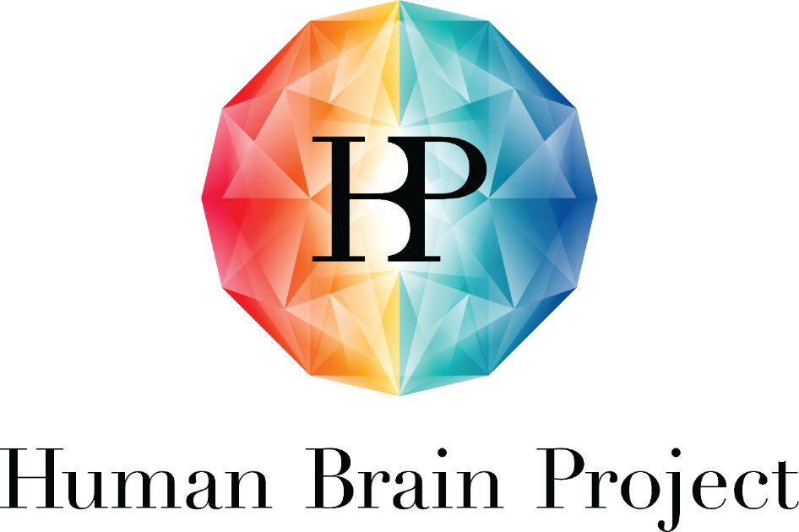

Project Number: | 945539 | Project Title: | Human Brain Project SGA3

Document Title: | EBRAINS Research Infrastructure Voucher Programme Call 2020, Proposal Template
Document Filename: | HBP SGA3 EBRAINS VOUCHERS 2020 - Proposal Template.docx
Dissemination Level: | PU = Public => please change this document to CO = Confidential after submission of the pre-proposal, here and in the footer
Abstract: | EBRAINS Research Infrastructure Voucher Programme Call 2020, Proposal Template
Keywords: | EBRAINS, Research, Infrastructure, Open measure, Open Calls, Voucher
Target Users/Readers: | Applicants, all interested
Call Open: | 18 Sept 2020
Proposal Submission Deadline: | 6 Nov 2020 17:00 Brussels time
Proposal submission online platform | HBP Open Call Platform
More information: | vouchers@humanbrainproject.eu

This template is for proposals made in response to the EBRAINS Research Infrastructure (RI) Voucher Call.
The HBP is providing its expertise and skills to researchers and groups around the world through the EBRAINS Research Infrastructure Vouchers.
The Vouchers give researchers outside the project access to the EBRAINS services and its engineers; with the help of the engineers, the Voucher winners will be able to implement new infrastructure capabilities to solve specific problems not covered by the current RI toolset. The focus is on projects that will be relevant for using and/or contributing to the further development of EBRAINS services.
The aim is to meet the needs of the user community in a dynamic new way and to establish collaborations that pursue technology innovation and engineering solutions of mutual interest and benefit.
The Call for applications for the RI Voucher Programme has the deadline on 6 November 2020 17:00 Brussels time (CET).
The Call is open to all non-HBP researchers, with separate target groups from academic, non-academic research (including hospitals), industry and pharma (SMEs and companies).
Important note: While benefiting from tailor-made developments and solutions for their projects, Voucher winners will not receive any direct funding for their work from the HBP. The Vouchers fund the work of the EBRAINS engineering teams to implement the RI features requested by the Voucher winners.
The number of applications that an EBRAINS contact (PI and respective lab) can co-submit is limited to two. Should there be more requests, the EBRAINS contact will forward them to other partners within the HBP, if possible.
The size of each Voucher will depend on the personnel and travel costs required to realise the new RI capability and to allow for intensive exchange between the participants. The Vouchers are worth between 4 to 12 months of engineering/development time (maximum 12 person months (PMs), maximum duration 12 months), plus up to 4% travel costs.
Interested applicants should get in contact with the HBP already during the application process to work together with the EBRAINS engineers concerned to refine their proposals.
If you have any questions, contact us at vouchers@humanbrainproject.eu.
For more information, see the Guide for Applicants on the HBP Open Call Platform at: https://opencalls2.humanbrainproject.eu/call/ebrains-research-infrastructure-voucher-programme-call-2020.

Application process & planned timeline
Call opens: 18 September 2020.
Submission Deadline (green part): 6 November 2020 17:00 Brussels time (CET).
Internal Deadline – Contribution of EBRAINS platform/service contact (blue part): 30 November 2020 17:00 Brussels time (CET).
The announcement of the winners is expected in February/March 2021.
The practical work of the platform developers is supposed to start between April and June 2021.
The Voucher projects have a maximum duration of 12 months.
Please enter the details of your proposal in English in the form below (green part) and submit it as a single PDF file to the HBP Open Calls Platform at https://opencalls2.humanbrainproject.eu/call/ebrains-research-infrastructure-voucher-programme-call-2020, any time before 30 October 2020 17:00 Brussels time (CET).
The blue part of the proposal will be completed by the EBRAINS platform/service contact by 30 November 2020.

Proposal Template for Applicants (green part only)
Project
Title of the project
Acronym

Project leader (must be outside the HBP)
First name, family name
Email
Affiliation (university, hospital, institute, company, SME, etc.)
Country
Project member(s) (HBP external) (please replicate for each member)
First name, family name
Email
Affiliation (university, hospital, institute, company, SME, etc.)
Country
HBP EBRAINS contact name 1
Platform
First name, family name
Email
Institution
HBP EBRAINS contact name 2
Platform
First name, family name
Email
Institution

1. Project summary
What is the scientific question you are trying to answer?
What is the background and state of the art in this domain?
Which EBRAINS Platform(s) or service would the project be using or contributing to?
How would the proposed work go beyond the state of the art, with help from the EBRAINS Research Infrastructure?
What is the novelty in your approach?
In research activities when human beings are involved as subjects or end users, gender differences or other diversity factors may exist. In these cases, is the gender dimension and relevance of scientific questions on gender or other diversity factors (e.g. age) in the research content addressed as an integral part of the proposal?
Max. 1,000 words
2. Describe the contributions (data, models, software) and background that you are willing to bring in.
Add links to publicly available material (software, data, publications), in general to information that helps to understand your request and background.
Generated results will be integrated into EBRAINS. Are you interested to share further data in EBRAINS?
Is this a follow-up proposal of a former voucher project? yes/no
In case of a follow-up proposal, enter all relevant links to generated data and features generated by the former project. Please note: Follow-up proposals based on former Voucher work are not recommended, only if it can be proven that the output of the first project was fully integrated into EBRAINS and if the follow-up proposal is of exceptional relevance
3. Are there any licensing or intellectual property issues that you can foresee for any of the listed background (above)?
Do you have a commercial interest in any RI development you may undertake with the HBP?
Do you have any companies already interested in future commercialisation, or do you have any targeted for this purpose?
Specify.
4. Specify the Use Case (complete this in collaboration with an EBRAINS contact prior to the submission date on 6 November 2020)
Min. 200 words
What will the new feature/infrastructure element be used for?
What results or output do you expect?
Who else will be interested in using the application/ benefit from the implementation? Give details on the likely user group(s) and user numbers, if possible.
5. Responsible Research and Innovation
Ethics: Are there any ethical issues (described in the Horizon2020_Ethics_Guidance.pdf) that apply now or could come across during implementation of the project?
Do you have the required documents ready, so that the Voucher work can start?

Equal opportunities: For teams, is the diversity aspect (gender, age, career stage, other factors) taken into consideration/ are there any measures in place? If there is a gender imbalance, are measures planned to improve gender equality?
6. Do you receive any funding from a funding body for work associated with the proposed project? If yes, please specify the funding body, the amount and the duration. Please state whether the funder approved the application to this Call.

Contribution of the EBRAINS contact (blue part)
IMPORTANT: THIS PART SHOULD BE COMPLETED BY THE APPROPRIATE EBRAINS CONTACT, NOT THE APPLICANT.
The EBRAINS contact completes this part after the submission deadline on 6 November 2020.
The deadline for the EBRAINS contact to upload this part to the Open Call Platform https://opencalls2.humanbrainproject.eu/call/ebrains-research-infrastructure-voucher-programme-call-2020 is 30 November 2020, 17:00 Brussels time.
EBRAINS Contact - Lead
Platform/ Service category (SC1-SC6)
First name, family name
Email
Partner institution
1. Implementation and Feasibility:
- Specify the feasibility of implementing the proposed work in the EBRAINS services (considering the available resources and requested PMs).
- Estimate the needed resources (as justification for the costs, see 4. Budget below).
- Who will maintain the application or service afterwards?
- Are you considering the gender and diversity aspect in your team?
Max. 1,000 words
2. Relevance for EBRAINS:
- How much is this development desired?
- What will be the output (such as a software release, dataset, model, prototype). Specify.
- Will the generated data, software, knowledge etc. be integrated in EBRAINS by month 12 from the project start?
- How does the work contribute to the HBP Objectives? See Annex
- Confirm that you support this Voucher to be developed into a Partnering Project https://www.humanbrainproject.eu/en/about/project-structure/partnering-projects/, if awarded:
- yes/no
- If no, please explain
Max. 1,000 words
3. Impact and Innovation potential
- How do you assess the attractiveness of this technology development for new user communities (quality and quantity)?
- Scientific and/or industrial value of the IPR strategy
- Exploitation potential
Max. 400 words
Current TRL: |  | Estimated date when TRL >=7 could be reached (ready for commercialisation): For more information, see the TRL sheet on the submission page. https://opencalls2.humanbrainproject.eu/call/ebrains-research-infrastructure-voucher-programme-call-2020:  Proposed date for TRL >=7:
4. Budget (IMPORTANT: TO BE COMPLETED BY THE EBRAINS PLATFORM CONTACT)
Summary of staff effort
The maximum you can apply for are 12 PMs (in total). The maximum Voucher duration is 12 months.
Into which HBP Task should the Voucher project be anchored (preferably HLST Tasks)?
Your name as EBRAINS platform contact and project leader & institution  (NOT the name of the person in your group who would implement the work) | Requested Person Months (max 12 PM)  AND  Personnel cost rate/month in Euro (excluding 25% overhead); justify the rate (ask support from your admin representation, if necessary)  - Post doc  cost rate/month  - Engineer/developer cost rate/month  - Other person cost rate/month |  |  | HBP Task for the Voucher (SGA3)  (only Tasks in WP4, WP5 and WP6)
Your name: xxx  Institution: xxx | PM: xxx  Personnel cost/month (EURO): xxx  Justification: xxx |  |  | Task: Tx.y
Additional EBRAINS platform contact name(s)
Name: xxx  Partner institution: xxx | PM: xxx  Personnel cost/month (EURO): xxx  Justification: xxx |  |  | Task: Tx.y

Travel budget – for exchange and collaboration in the frame of the Voucher project
Please note: The travel budget is reserved to invite the external non-HBP partners/Voucher winners to attend HBP events (in-person meetings, HBP Summit, trainings, group visits etc.)
EBRAINS platform contact name (project lead) & Institution | Task (in the HBP) | Budget (max. 4% of total personnel costs, in EUROs)
Name: xxx  Institution: xxx | Task: Tx.y

ANNEX: SGA3 Project Objectives and Work Package Objectives
Project Objective | Work Package Objective
PO1. Establish a sustainable European scientific research infrastructure, EBRAINS, leading to an increased use and adoption of FAIR data, web-based analyses, model building, simulation, atlasing, and virtual experiments for brain research and brain-inspired sciences. | - WPO4.1. FAIR data services: Access to and storage of high-quality neuroscientific data, facilitating data re-use in the scientific community  - WPO4.2. Brain atlases services: Increased performance, functionality and use of the HBP multi-scale and multi-modality brain atlases, and related tools and workflows  - WPO4.3. Human Intracranial EEG data service: Established curated multiscale neurophysiological (intracranial EEG) database available in Europe with supporting tools and workflows  - WPO4.4. High-Level Support Team (HLST), EBRAINS community, and science incubation: Increased use of EBRAINS by expanding engagement with brain scientists, AI researchers, and other stakeholders  - WPO5.1. Brain modelling and simulation  - WPO5.2. Closed-loop Neuroscience, Robotics and AI service  - WPO5.3. EBRAINS software components integration, testing and delivery  - WPO6.1. Neuromorphic computing: Improved online, interactive Neuromorphic Computing (NMC) resources.  - WPO6.2. Federated infrastructure: Improved, operable and sustainable federated HPC, Cloud, storage and network infrastructure available to the EBRAINS community based on ICEI resources and services  - WPO6.3. Collaborative workspaces: Increased maturity of collaborative tools and improved integration into the infrastructure to lower the barrier to adopting the EBRAINS RI  - WPO6.4. ESFRI: Secured long-term sustainability of EBRAINS
PO2. Provide a multi-level atlas of the human brain - the first of its kind that links microstructural detail and inter-subject variability. | - WPO1.1. Increased capacity of neuroscientists for multiscale neural activity modelling of the human brain network  - WPO2.2. Strengthened ethical and philosophical framework for the experimental and computational explorations of cognition and consciousness
PO3. Increase the capacity of neuroscientists for multiscale neural activity modelling of the human brain network. | - WPO2.1. Increased availability of integrated data and computational models supporting brain state transitions, network complexity and cognitive functions
PO4. Increase the availability of integrated multiscale data and computational models supporting brain states transitions, network complexity and cognitive functions. | - WPO3.1. Enhanced real-world task performance through biologically plausible adaptive cognitive architectures running on neuromorphic hardware and closed-loop Neurorobotics Platform
PO5. Enhance real-world task performance through biologically plausible adaptive cognitive architectures running on neuromorphic hardware and a closed-loop Neurorobotics Platform. | - WPO1.1. Increased capacity of neuroscientists for multiscale neural activity modelling of the human brain network  - WPO2.2. Strengthened ethical and philosophical framework for the experimental and computational explorations of cognition and consciousness  - WPO3.1. Enhanced real-world task performance through biologically plausible adaptive cognitive architectures running on neuromorphic hardware and closed-loop Neurorobotics Platform  - WPO4.1. FAIR data services: Access to and storage of high-quality neuroscientific data, facilitating data re-use in the scientific community  - WPO9.1. To consolidate HBP international collaboration in the articulation of an ethics strategy for identifying, addressing, and managing the ethical and social issues that neuro-ICT faces at both the local and global level by the end of SGA3  - WPO9.2. To strengthen the ethical and social acceptability and desirability, and to increase understanding of legal compliance of HBP research and EBRAINS infrastructure to ensure societal benefit"
PO6. Ensure that neuroscientific insights at the interface of neuro-inspired computing and technology are being translated into a benefit for patients with brain diseases. | - WPO4.5. Medical Informatics Platform (MIP): Expand deployment, optimize end-users experience and develop early stage clinical application
PO7. Ensure an ethically and legally compliant infrastructure and promote embedding of Responsible Research and Innovation, and of neuro- and data ethics in EBRAINS. | - WPO9.1. To consolidate HBP international collaboration in the articulation of an ethics strategy for identifying, addressing, and managing the ethical and social issues that neuro-ICT faces at both the local and global level by the end of SGA3  - WPO9.2. To strengthen the ethical and social acceptability and desirability, and to increase understanding of legal compliance of HBP research and EBRAINS infrastructure to ensure societal benefit  - WPO9.3. To enhance the proportional representation of genders at all career levels, the collaboration in a diverse workforce as well as gender and diversity as research topics."

